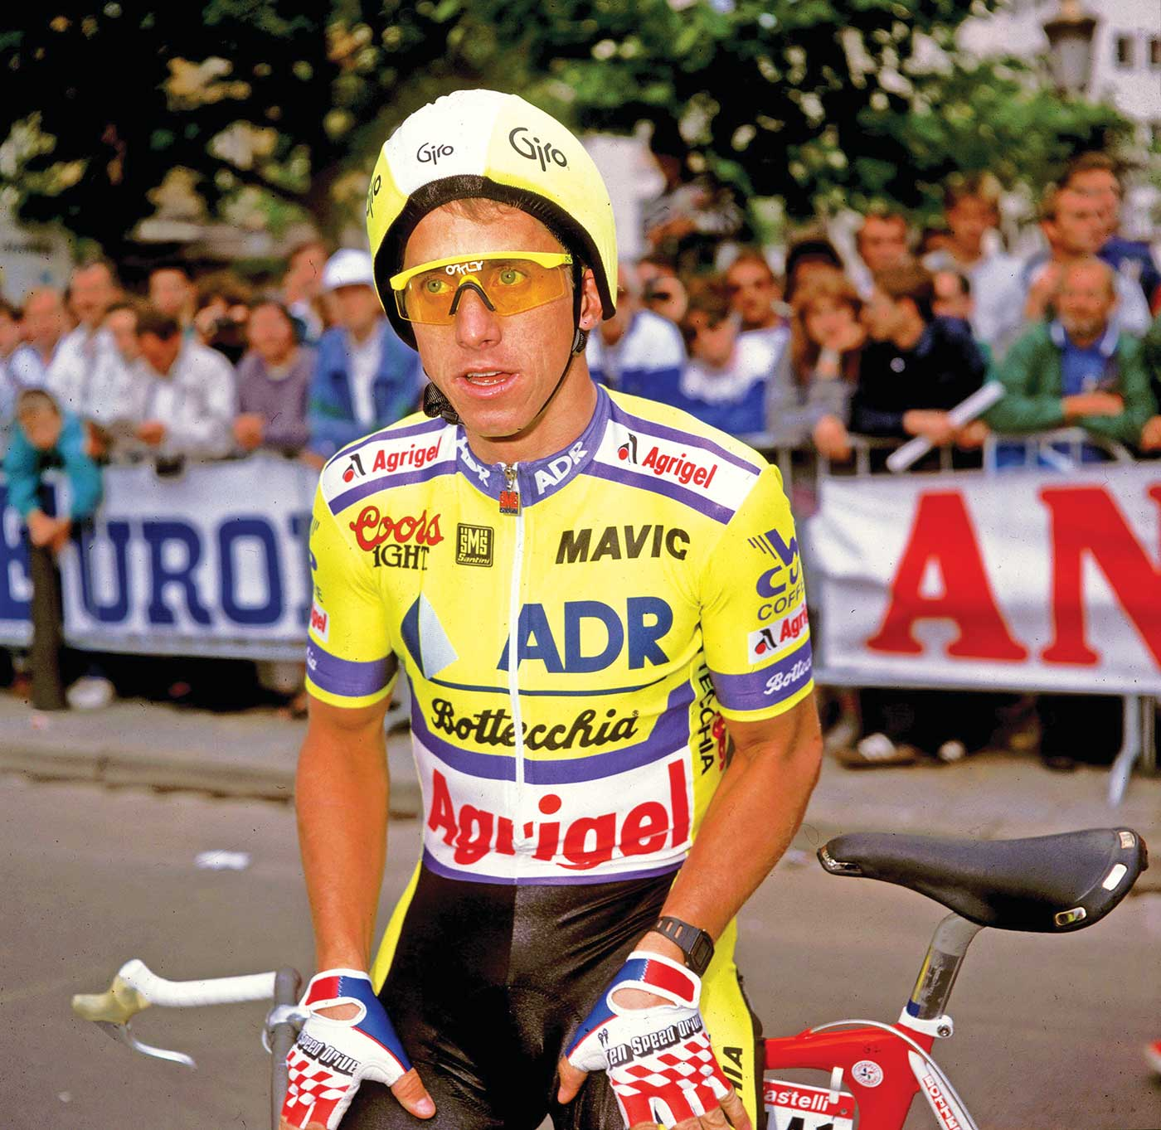

**Greg LeMond**

Greg LeMond was born in 1961 in California, USA. As a teenager he used to go cycling. He soon started winning races against older cyclists and became the youngest person to join the US Olympic cycling team. Later, in 1986 he won the famous Tour de France.

Then, in 1987, something terrible happened, LeMond had an accident and almost died. Luckily, doctors saved his life. It looked like his cycling days were over for good.

In 1988, LeMond decided to start cycling again. In the beginning it wasn’t easy for him. When he raced in the 1989 Tour de France, everyone thought he would have little success. Unbelievably, he won! That year, he also won the “Sportsman of the Year” award. LeMond won the Tour de France again the year after, placing is name in sorting history books forever.

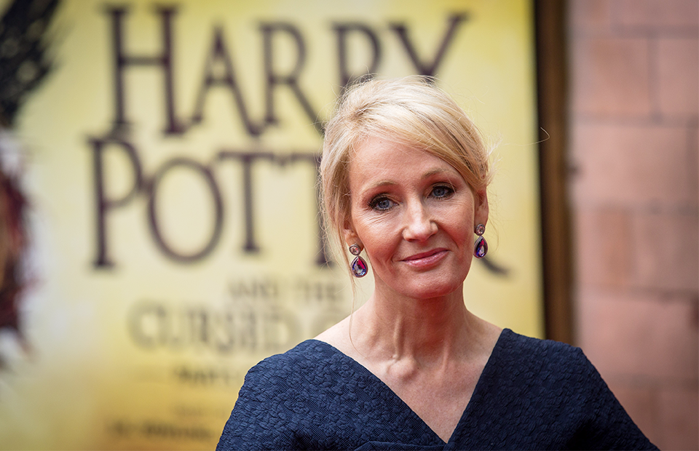

**Joanne Rowling**

Joanne Rowling is a famous British writer. She was born on July 31st, 1965, in Yate, which is north-east of Bristol. Her father was an engineer and her mother was a science technician. She is tall and slim with short blond hair and blue eyes. She started writing fictional stories when she was nine. Her first listener was her younger sister Dianne.

Joanne’s childhood wasn’t easy. Her mother was often ill and she had to take care of herself and her sister. School years were also difficult. In 1986 she moved to London and started working as a secretary. In 1991, she went to Portugal to teach English. In Portugal she met her future husband and in 1993 she had a daughter Jessica. However, she soon got divorced and moved to Edinburgh with her daughter. In Scotland she received a grant to finish the novel about “Harry Potter and the Philosopher’s Stone”.

All in all, she wrote seven books about Harry Potter. Her fantasy books about Harry Potter became the best-selling books in the history of literature. These books have become the basis for a series of films, which were also successful.

There are many reasons why I admire Joanne Rowling. She is an intelligent and imaginative person. She is very determined as she did not give up on her career and dreams because of some difficulties and divorce. She proved that anything is possible and that dreams can come true.

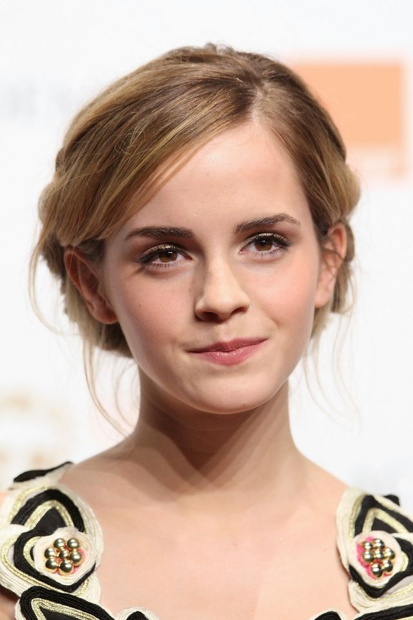

**Emma Watson**

Emma Watson is a British actress and social activist. She was born on April, 15, 1990 in Paris, France, but raised in England. She is of medium height and slim with shoulder-length fair hair and brown eyes.

Watson attended the [Dragon School](https://en.wikipedia.org/wiki/Dragon_School) and trained as an actress at the [Oxford](https://en.wikipedia.org/wiki/Oxford) branch of [Stagecoach Theatre Arts](https://en.wikipedia.org/wiki/Stagecoach_Theatre_Arts). In 1999, when she was nine she became filming her first role as Hermione Granger in “Harry Potter and the Philosopher’s Stone”. Between 2001 to 2011, she appeared in all seven Harry Potter films and became an international teen star as the films became very popular.

Watson continued her film career with new roles in films such as “The Perks of Being a Wallflower”, “the Bling Ring” and “This is the End”.

In 2014 she was appointed as a [UN Women](https://en.wikipedia.org/wiki/UN_Women) [Goodwill ambassador](https://en.wikipedia.org/wiki/Goodwill_ambassador) and helped launch the UN Women campaign “[HeForShe](https://en.wikipedia.org/wiki/HeForShe" \o "HeForShe)”, which advocates for [gender equality](https://en.wikipedia.org/wiki/Gender_equality).

There are many reasons why I admire Emma Watson. She is creative, hardworking and artistic person. As an actress she is talented and charismatic. She has earned worldwide fame, critical praise and around 60 million dollars.

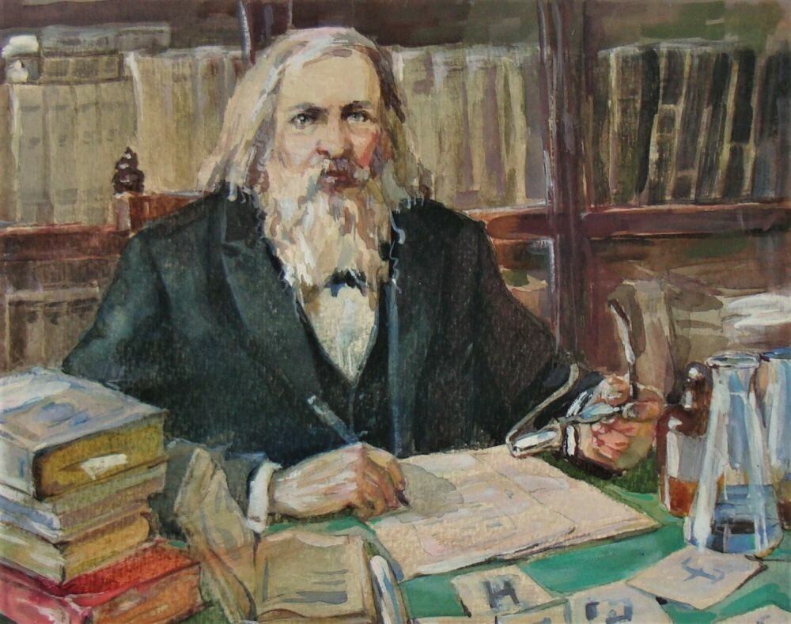

**Dmitri Ivanovich Mendeleev**

Dmitri Ivanovich Mendeleev was born on 8 February 1834 near Tobolsk. Mendeleev’s parents were Maria Mendeleeva Kornilieva and Ivan Mendeleev. According to the different sources there were approximately seventeen children in their family. Mendeleev was the youngest child. His father worked as a teacher but he became blind and stopped working. As a result Maria Mendeleeva began to work and re-established the glass factory which belonged to her family.

When Mendeleev was 13 he entered the Gymnasium in Tobolsk. In 1849 his family moved to Saint Petersburg. In 1850 Mendeleev joined The Main Pedagogical Institute and graduated in 1855. After teaching in the Russian cities of Simferopol and Odessa, he returned to St. Petersburg to earn a master’s degree. Mendeleyev continued his studies abroad, with two years at the University of Heidelberg. As a professor, Mendeleyev taught first at the St. Petersburg Technological Institute and then at the University of St. Petersburg, where he remained through 1890.

Mendeleyev was married twice, to Feozva Nikitichna Leshcheva in 1862 and to Anna Ivanova Popova in 1882. He had two children from his first marriage: Olga and Vladimir. His other children from the second marriage were Lyubov, a pair of twins and son Ivan.

Mendeleev was a Russian [chemist](https://en.wikipedia.org/wiki/Chemistry) and inventor. He is best known for formulating the [Periodic Law](https://en.wikipedia.org/wiki/Periodic_Law) and creating a farsighted version of the [periodic table of elements](https://en.wikipedia.org/wiki/Periodic_table). Mendeleev was also first-class physicist, a researcher in the fields of hydrodynamics, meteorology, geology, certain branches of chemical technology and other disciplines and an original thinker in the field of economy. He worked on the theory and practice of protectionist trade and on agriculture.

In the later years of his career, Mendeleyev was internationally recognized and received honorary awards from Oxford and Cambridge, as well as a medal from the Royal Society of London.

Mendeleyev died on February 2, 1907. At his funeral in St. Petersburg, his students carried a large copy of the periodic table of the elements as a tribute to his work. I think we all must give him our respect and admiration.

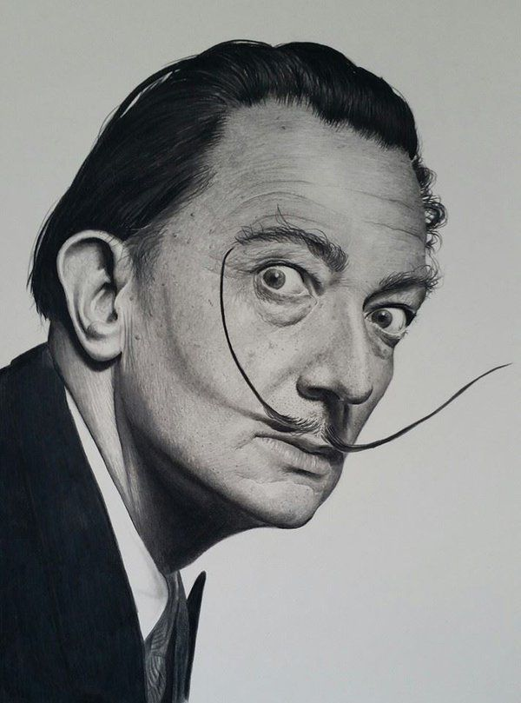

[**Salvador Dalí**](https://en.wikipedia.org/wiki/Salvador_Dal%C3%AD)

Salvador Dali was a famous Spanish surrealist artist. He was born on 11th May, 1904 in Figueres, Catalonia, Spain.

At an early age, Dali's parents encouraged him to produce unusual drawings. Dalí received his formal education in fine arts in Madrid.

In August 1929, Dali met his muse, inspiration, and future wife Gala. Dali's artistic repertoire included painting, graphic arts, film, sculpture, design and photography, at times in collaboration with other artists. He also wrote fiction, poetry, autobiography, essays and criticism. Dali was highly imaginative, and he also had eccentric manners.

Salvador Dali died in his hometown on 23rd January, 1989. He was 84 years old. He was a genius.

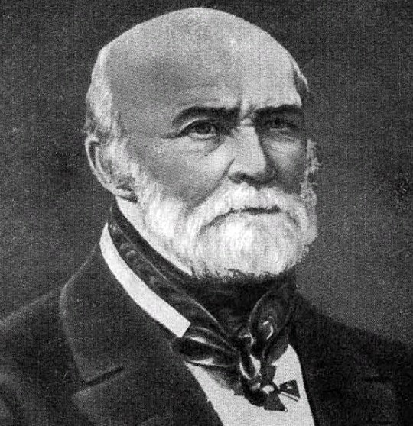

**Nikolay Ivanovich Pirogov**

Nikolay Ivanovich Pirogov, was born in Moscow, in the family of a treasurer, on the 25th of November 1810, and he was the thirteenth child.

He always had exceptional mental skills. At the age of 14 Pirogov enrolled as a student in the medical Faculty of Moscow University and 3 years later he got his doctor’s diploma. As one of the best graduators he was sent to Tartu to take a special course. Pirogov brilliantly completed the course and in 1833 very successfully defended his thesis for the degree of Doctor of medicine. Then he became professor and head of the major surgical clinic at the University of Tartu. A few years later he was elected professor of the Medico-Surgical academy of St. Petersburg. Pirogov was married twice and he had two sons from his first marriage, Nikolay and Vladimir.

Pirogov was a prominent [Russian](https://en.wikipedia.org/wiki/Russian_Empire) scientist, medical doctor, [pedagogue](https://en.wikipedia.org/wiki/Pedagogue), [public figure](https://en.wikipedia.org/wiki/Public_figure), and corresponding member of the [Russian Academy of Sciences](https://en.wikipedia.org/wiki/Russian_Academy_of_Sciences). He is considered to be the founder of [field surgery](https://en.wikipedia.org/wiki/Field_surgery), and was one of the first surgeons in Europe to use [ether](https://en.wikipedia.org/wiki/Diethyl_ether) as an [anesthetic](https://en.wikipedia.org/wiki/Anaesthetic). He was the first surgeon to use anesthesia in a field operation, invented various kinds of surgical operations, and developed his own technique of using [plaster casts](https://en.wikipedia.org/wiki/Orthopedic_cast) to treat fractured [bones](https://en.wikipedia.org/wiki/Bone).

I admire this scientist, because he made a lot for people and he is one of the most widely recognized Russian physicians.